# Minunni System Design Document

## UML Diagrams

### UML Use Case Diagram

**UML Activity Diagrams**

### UML Sequence Diagram

### UML Class Diagram

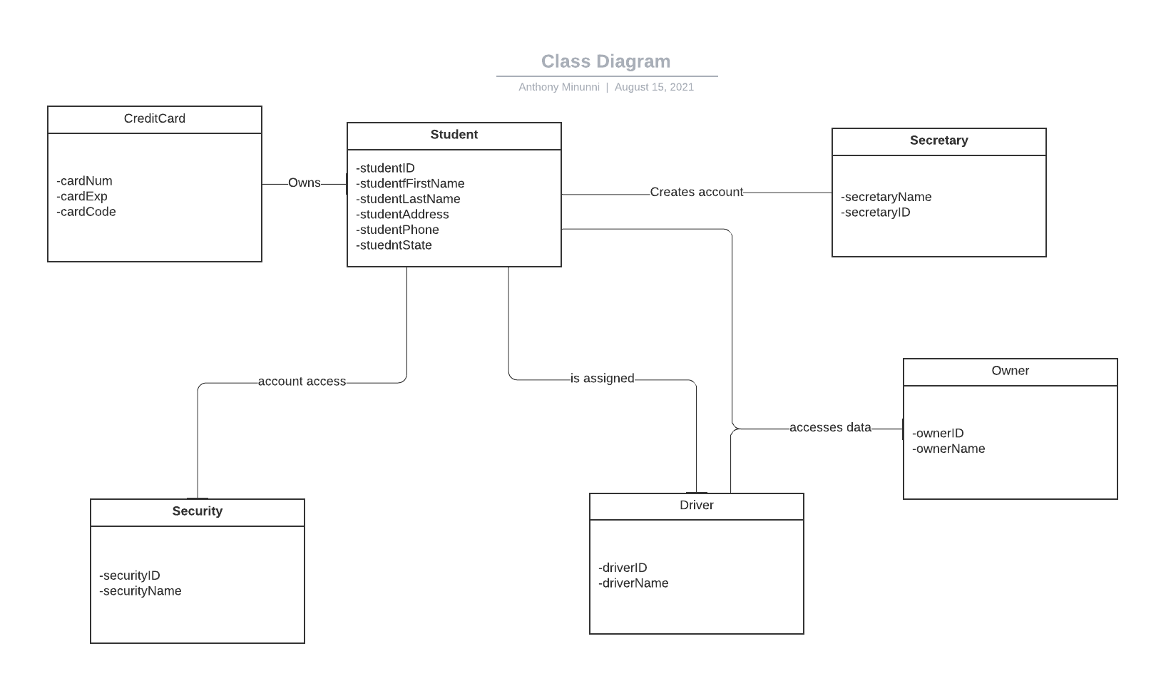

## Technical Requirements

The program will be run off the cloud to reduce maintenance concerns and provide security for sensitive data. There will be a database connected to the program to hold customer and employee account information and payment information. This information will be encrypted, and only security will see account passwords only when given permission. The program will be browser-based as opposed to an application, so the cloud resources will be optimized to have quick loading times for the amount of users that will be using the program. The program will be connected to DMV services so any updates made by the DMV will be reflected in the lesson plans provided in the program. There are no plans for future updates to the system.